Homework 2
Histogram Equalization
The objective of this assignment is to understand and implement the concept of histogram equalization to enhance the contrast of a digital image.
You will need to apply both the Global Histogram Equalization and Local Histogram Equalization to the same grayscale image, implement them in Python, and document any observations in your report
This assignment allows the use of the OpenCV API: equalizeHist(), but you will only receive basic score. If you can implement the underlying logic yourself, you will earn a higher score.
The following is a diagram included in the report, using Global HE as an example.
Bonus: Implementing any Histogram Equalization algorithms mentioned in the course will provide additional credit.
 | Before Global HE | After Global HE
images | 
Histogram | 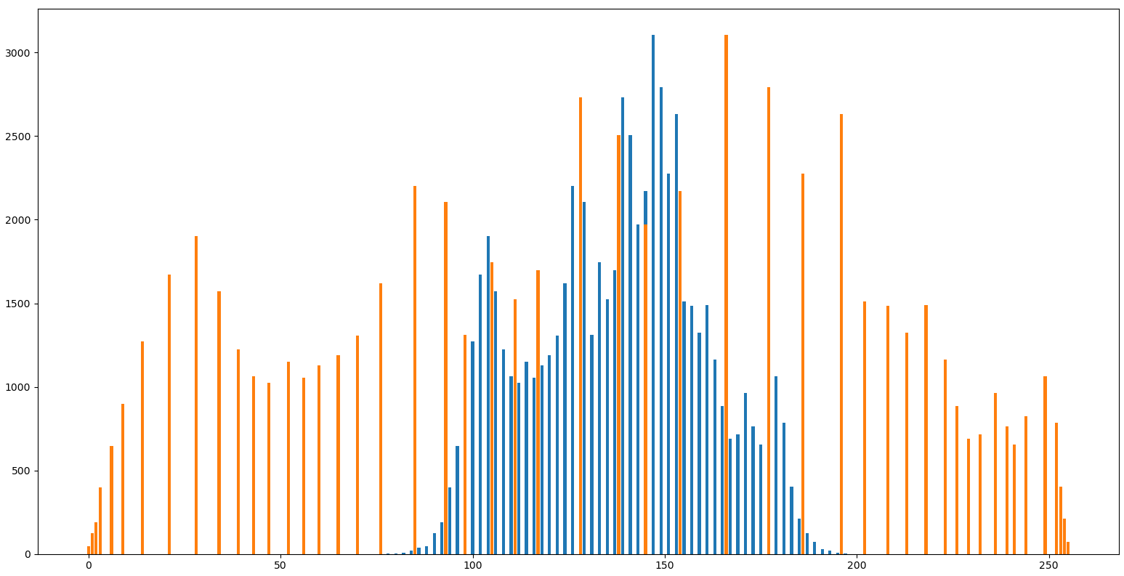
The report must contain the following(Submit the PDF)：
1. Screenshots：Display the original image, the image after Histogram equalization
2. Explain：Your method (if you have other try) with experiment
3. Discussion：interesting finding, difficulties you encountered, insights you observe

